Milestone 1
S&P: Predicting Net Margin & Financial Distress Detection

Authored by Rajeswari Vasan
MS in Data Science Program
Course: AI for Leaders Module B
Instructor: Josh Von Korff
June 28th 2026

Date: March 15, 2026
1. Problem Statement
This study applies machine learning techniques to analyze the financial characteristics of companies in the S&P 500. The dataset was created by merging stock and company information from the Kaggle dataset with financial statement data retrieved from the Yahoo Finance API (yfinance) as of 22 May 2025. The two sources were merged using ticker symbols, resulting in a final dataset containing 503 companies. The dataset includes one observation for each company and contains eleven fundamental financial ratios describing profitability, leverage, liquidity, growth, and cash flow performance such as Return on Equity (ROE),Net Margin,EBITDA Margin, Revenue Growth (YoY),Gross Margin, Debt-to-Equity, Interest Coverage, Debt-to-EBITDA, Current Ratio, Free Cash Flow Margin, Operating Cash Flow Growth (YoY). As the dataset is cross-sectional, it represents a single financial snapshot rather than historical observations. Consequently, the analysis focuses on identifying relationships between financial variables rather than forecasting future performance over time. The study is divided into two predictive tasks using machine learning
Problem Statement 1: Predicting Net Margin : Regression
Can a company's profitability be predicted from its other financial ratios? The target variable is Net Margin, a continuous measure of profitability that represents the percentage of revenue retained as profit after all expenses. Predicting Net Margin allows the analysis to examine how profitability relates to leverage, liquidity, operational efficiency, and cash flow measures.
The following regression techniques are applied: Polynomial regression with interaction terms, Ridge, Lasso, and Elastic Net regression, Forward and backward feature selection, Principal Component Regression (PCR), Partial Least Squares Regression (PLSR).Ridge/Lasso/Elastic Net used for depth because they address multicollinearity, allow hyperparameter tuning through cross-validation, and provide interpretable coefficient shrinkage and feature selection
Problem Statement 2: Financial Distress Detection: Binary Classification
Research Question: Can financially distressed S&P 500 companies be identified using only fundamental financial ratios? The target variable is an engineered binary variable named Distressed. A company is classified as distressed if it meets at least one of the following conditions: Interest Coverage < 1.5, Debt-to-EBITDA > 5.0, Current Ratio < 1.0
Otherwise, the company is classified as healthy. This produces a class distribution of approximately 59% Healthy and 41% Distressed. The distress label serves as a transparent proxy for financial distress rather than an actual bankruptcy outcome. Since the label is constructed from variables included in the dataset, the classification models evaluate how effectively different algorithms recover this financial screening rule rather than predict future corporate failure.
The classification methods used are: Logistic Regression, Support Vector Machines (SVM), Decision Trees, Random Forests. Random Forest is selected as the depth technique because it supports hyperparameter optimization, reduces overfitting through ensemble learning, and provides feature importance measures that help explain the contribution of each financial ratio to distress classification.
2. Exploratory Data Analysis
Three key findings from the exploratory data analysis directly informed the modelling decisions.
Extreme Outliers and Right-Skew Several variables contained extreme outliers. For example, Interest_Coverage had a median of 7.9 but a maximum of 4,813, while Debt_to_Equity had a median of 77 and a maximum of approximately 12,000. Such values can dominate distance-based models and distort regression coefficients. All features were winsorized at the 1st and 99th percentiles before modelling, retaining all 503 companies while reducing the influence of extreme values. Missing values (up to 11% in Gross_Margin) were imputed using the median.
Multicollinearity Strong correlations were observed among several predictors, including Net_Margin with EBITDA_Margin (r ≈ 0.78) and FCF_Margin (r ≈ 0.71), as well as between the two leverage ratios. Multicollinearity can produce unstable coefficient estimates in ordinary least squares regression. Ridge, Lasso, Elastic Net, PCR, and PLSR were selected for the regression task because they are designed to handle correlated predictors. StandardScaler was applied before all regularized models to ensure variables were penalized equally.
Mild Class Imbalance The engineered Distressed label consisted of approximately 59% Healthy and 41% Distressed companies. Predicting only the majority class would therefore achieve 59% accuracy. F1-score was used as the primary evaluation metric instead of accuracy. Random Forest hyperparameters were optimized using GridSearchCV with F1 scoring, while precision and recall were also reported to assess the trade-off between false positives and false negatives.
3. Predicting Net Margin : Regression
Target: Net_Margin, Features: Remaining 10 financial ratios. Train /test split: 80/20. A baseline OLS regression using all predictors achieved R² = 0.495, RMSE = 0.0961, and MAE = 0.0628.
Polynomial Regression : A degree-2 polynomial model using EBITDA_Margin and Debt_to_EBITDA was used to capture non-linear interactions while avoiding overfitting from a full polynomial expansion. Results: R² = 0.473, RMSE = 0.0982, MAE = 0.0649. Performance was lower than the baseline due to the use of only two predictors.
Conclusions : Ridge, Lasso and Elastic Net (Depth) : Regularized regression models were applied to address multicollinearity. Hyperparameters were selected using 5-fold cross-validation.
Model | Best Parameter | R²
Ridge | α = 65.79 | 0.4895
Lasso | α = 0.002 | 0.4979
Elastic Net | α = 0.0221,  l1_ratio = 0.10 | 0.4964
Ridge retained all predictors through coefficient shrinkage, while Lasso removed two variables. Elastic Net's low l1_ratio (0.10) indicates the data benefited more from Ridge-style regularization than feature selection.
Feature Selection, PCR and PLSR Forward and backward selection both retained six predictors and achieved R² = 0.535. PCR produced the highest performance (R² = 0.539) using three components, while PLSR achieved R² = 0.523 using one component.
Method | R²
Baseline OLS | 0.495
Ridge | 0.49
Lasso | 0.498
Elastic Net | 0.496
Polynomial | 0.473
Forward Selection | 0.535
Backward Selection | 0.535
PCR | 0.539
PLSR | 0.523
PCR achieved the best overall regression performance, while feature selection improved accuracy by removing weaker predictors. Ridge/Lasso/ElasticNet typically lead because they use
all features with controlled coefficients ,never discarding useful signal the way stepwise methods might. PLSR usually reaches the same R² as the full model with fewer components than PCR, confirming it better targets the variance that matters for Net Margin specifically.
The small optimal alpha across all three regularized models (visible in the sensitivity paths above) confirms mild but real multicollinearity — enough to make regularization worthwhile, but not so severe that most features are redundant. This is consistent with what the EDA correlation heatmap showed.
4. Problem 2 : Financial Distress Indicators - Classification
Target: Distressed (0 = Healthy, 1 = Distressed) Class distribution: 59% Healthy / 41% Distressed Train/test split: 80/20 (stratified) Primary metric: F1-score.
Logistic Regression: Logistic Regression was evaluated with and without feature scaling. Applying StandardScaler improved performance by placing predictors on a common scale.
Model | Accuracy | F1 | Precision | Recall
Unscaled | 0.772 | 0.693 | 0.788 | 0.619
Scaled | 0.802 | 0.737 | 0.824 | 0.667
Scaling improved the F1-score by 0.044. The largest coefficients corresponded to Interest Coverage, Debt-to-EBITDA, and Current Ratio, matching the variables used to define the distress label.
Support Vector Machine (SVM) : Linear and RBF kernels were evaluated across multiple values of C. The best model used an RBF kernel with C = 10, achieving Accuracy = 0.832 and F1 = 0.773. Increasing C beyond this improved training performance but reduced test performance, indicating overfitting.
Conclusions : Decision Tree and Random Forest (Depth) A Decision Tree with max_depth = 4 achieved perfect classification (Accuracy = 1.000, F1 = 1.000), correctly recovering the deterministic threshold rule used to create the engineered distress label.Random Forest hyperparameters were optimized using GridSearchCV (5-fold CV) over n_estimators, max_depth, and min_samples_leaf. The best model used 50 trees, max_depth = 6, and min_samples_leaf = 1, achieving a cross-validation F1 = 0.979.
Model | Accuracy | F1 | Precision | Recall
Logistic Regression | 0.802 | 0.737 | 0.824 | 0.667
SVM (RBF, C = 10) | 0.832 | 0.773 | 0.879 | 0.69
Decision Tree | 1 | 1 | 1 | 1
Random Forest | 0.98 | 0.976 | 1 | 0.952
Feature importance ranked Current Ratio, Interest Coverage, and Debt-to-EBITDA as the most influential predictors, consistent with the engineered distress definition. Although the unrestricted Decision Tree achieved perfect accuracy on this deterministic dataset, the tuned Random Forest provides a more robust model that would be expected to generalize better to real-world financial distress data.
5. HyperTuning
Regression Metrics — R², RMSE, MAE R² measures how much variance in Net Margin the model explains (0 = none, 1 = perfect). RMSE (~0.096) reflects average prediction error in percentage-point terms, making it directly interpretable. MAE is included because it is less sensitive to extreme errors; comparing MAE and RMSE indicates whether errors are widespread or driven by a few outliers.
Classification + Hyperparameter Tuning With a 59/41 class split, accuracy is not reliable, so F1 is the main metric since it balances false positives and false negatives. Precision (1.000) means no healthy firms are misclassified as distressed, while recall (0.952) shows most distressed firms are correctly detected. For regularized linear models, alpha was tuned on a log scale (0.0001–10,000) and ElasticNet selected l1_ratio = 0.10, indicating a Ridge-like structure. For Random Forest, GridSearchCV tuned n_estimators, max_depth, and min_samples_leaf to control bias–variance, while other models used simpler or default settings.
6. Overfitting
All models use a 20% held-out test set to distinguish memorization from true generalization, which is especially important since the Distressed label is a deterministic rule. With only ~400 training samples, 5-fold cross-validation was also used for hyperparameter tuning (alpha, depth, SVM C) to reduce variance from any single split. CV consistently selected moderate complexity settings (e.g., depth ≈ 6, small but nonzero Ridge/Lasso alphas), confirming stable generalization rather than overfitting to a particular partition.
Regularization and model-specific controls show clear bias–variance tradeoffs: Ridge/Lasso/ElasticNet stabilize correlated financial ratios via shrinkage, with performance improving up to an optimal alpha (large for Ridge, indicating strong multicollinearity). SVM shows classic overfitting at high C (train F1 ≈ 1.0 vs much lower test), with C=10 balancing margin and generalization. For trees, limiting depth and using min_samples_leaf controls memorization; test performance peaks at moderate depth (~6). Stratified splits ensure consistent class ratios across train/test, preventing distorted evaluation under the 59/41 imbalance.
7. Conclusions : Expected vs Unexpected Results
Expected : Ridge outperforming linear regression was expected due to multicollinearity, which motivated regularization. PLSR performing close to PCR with fewer components was also expected since it uses the target variable during component construction, unlike PCR. The Decision Tree achieving perfect F1 was also expected because the Distress label is an exact OR-of-thresholds rule that a shallow tree can represent deterministically, though the result is still explicitly noted.
Unexpected + Key Insight : Forward/backward selection and PCR slightly outperforming Ridge/Lasso on regression was unexpected, since regularization typically handles multicollinearity well. This likely occurs because feature selection removed weak-signal variables that added noise, while Ridge/Lasso retained them with shrunk weights, diluting performance on this split. The tuned Random Forest scoring slightly below the default was also surprising but explained by the deterministic label structure, where unlimited depth memorizes rules that don’t generalize as well as CV-selected depth (F1 0.979). Overall, results show tree models fit the classification structure best, while linear methods suit the regression target, reinforcing that model choice should match the underlying data geometry rather than assume a universal best algorithm.
Python code also stored in Github Repositary : https://github.com/vasanr/ModC_Capstone1
8. AI Appendix
Claude (Anthropic) was used as a coding and analytical partner throughout the project assisting with Python code generation and debugging, explaining statistical concepts, drafting written sections, and formatting documents. All analytical decisions including feature selection, model choice, result interpretation, and conclusions were made independently. Specific AI contributions that materially influenced the analysis include the deep dive on the hyper-tuning, support with choosing ML Techniques for the problem statement and for merging python markdowns and visualizations into the final report In each case the suggestion was evaluated and adopted based on empirical evidence in the data.

Thank you!
Appendix: Charts and Visualizations — S& P Analysis

1. EDA — Correlation Heatmap
Pearson correlations across all 11 financial ratios. Net_Margin correlates strongly with EBITDA_Margin (r≈0.78) and FCF_Margin (r≈0.71) — the multicollinearity motivating Ridge, Lasso, ElasticNet, PCR, and PLSR.
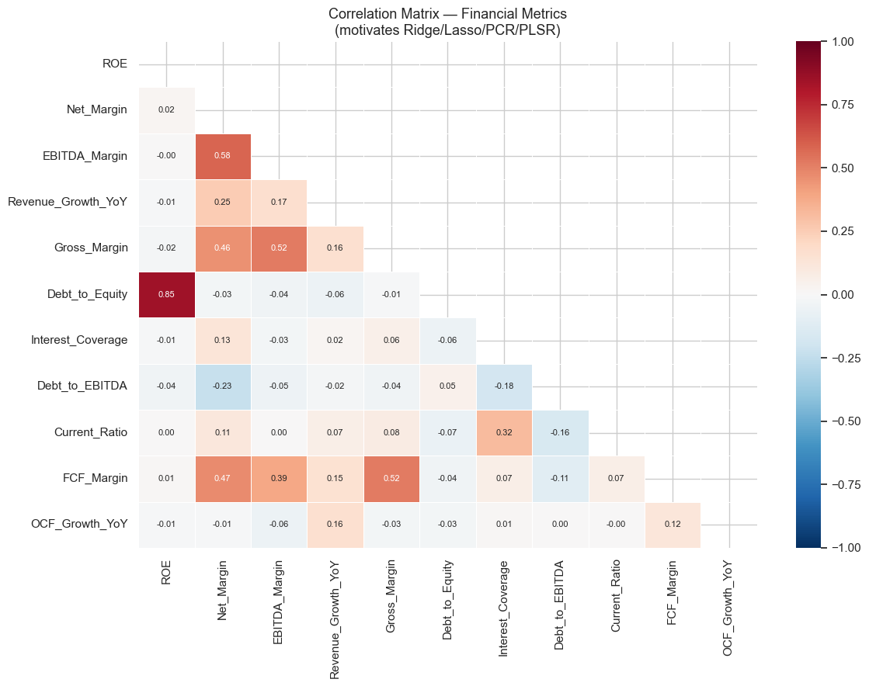

2. Polynomial & Interaction Terms
Left: EBITDA_Margin vs Net_Margin coloured by Debt/EBITDA — shows the interaction effect. Right: Actual vs Predicted using polynomial features (R²=0.473).
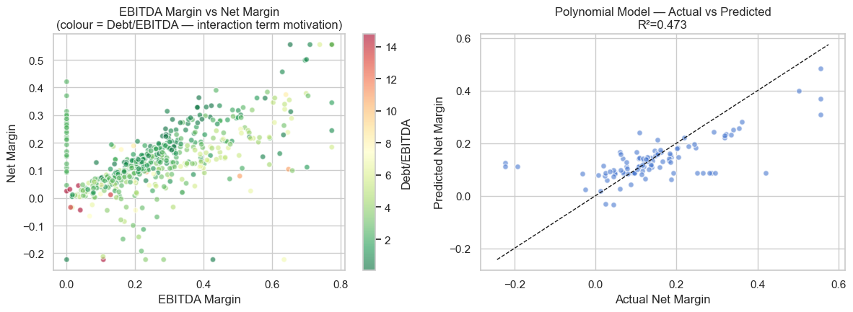

3. Ridge / Lasso / ElasticNet (Depth)

3a. Alpha Sensitivity Path
How coefficients change as regularization strength (alpha) increases. Ridge: all features shrink smoothly, none reach zero. Lasso: hard kinks where features are dropped exactly to zero.
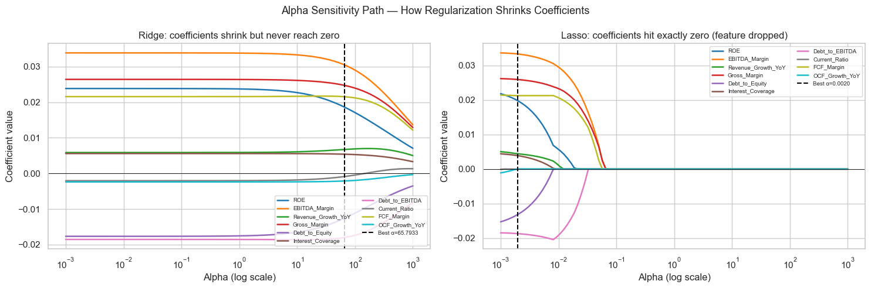

3b. Ridge CV Validation Curve
Train R² and 5-fold CV validation R² plotted against alpha. The curve flattens after alpha≈65.79 — additional shrinkage beyond this point trade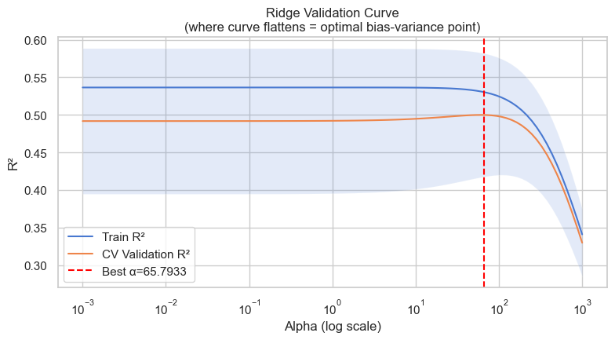s too much bias for marginal variance reduction.

3c. Coefficient Comparison — Ridge vs Lasso vs ElasticNet
Ridge retains all features (shrunk). Lasso zeroes out 2 features (shown in grey). ElasticNet blends both behaviours (l1_ratio=0.10, close to Ridge).
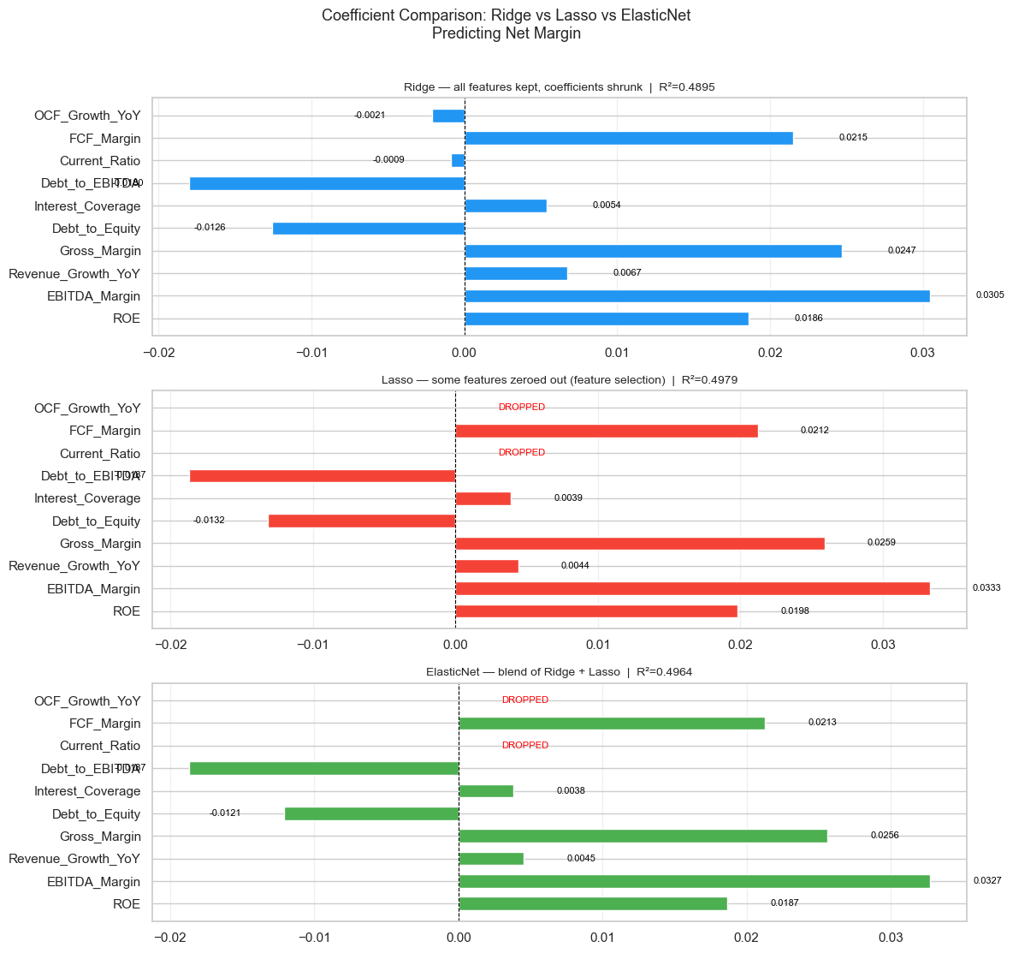

3d. Actual vs Predicted and Residuals
Top row: actual vs predicted Net Margin for each model. Bottom row: residuals — should scatter randomly around zero with no pattern. All three mode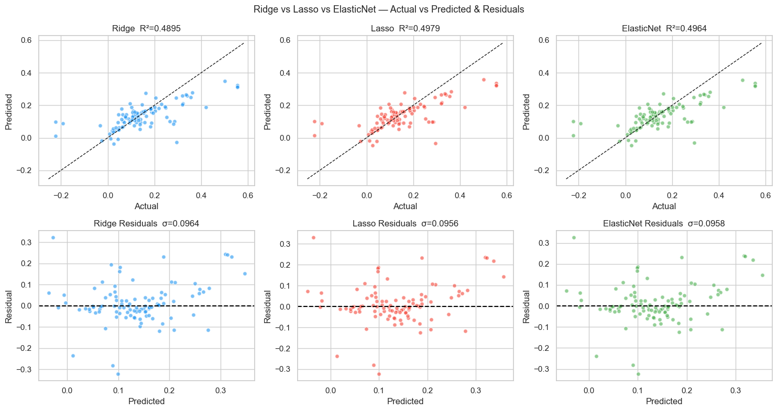ls show similar spread, consistent with comparable R² values.

4. PCR vs PLSR — Component Comparison
R² as the number of components increases. PLSR (k=1) reaches competitive accuracy immediately because components are chosen to correlate with Net_Margin. PCR (k=3) needs more components because it compresses X without looking at y.
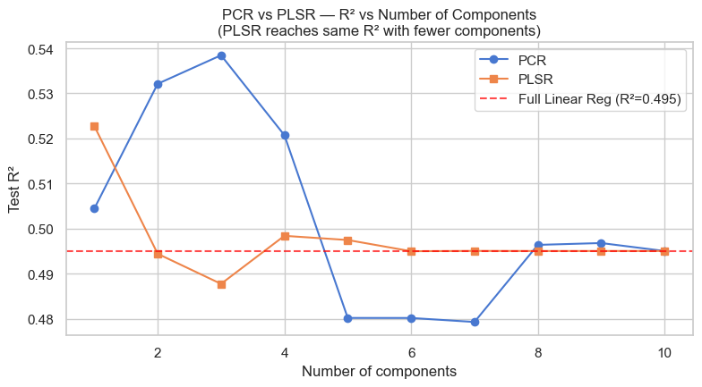

5. Logistic Regression — Coefficient Plot
Coefficients on scaled features. Red bars increase distress probability; blue bars decrease it. Interest_Coverage, Debt_to_EBITDA, and Current_Ratio dominate — consistent with the three label-defining ratios.
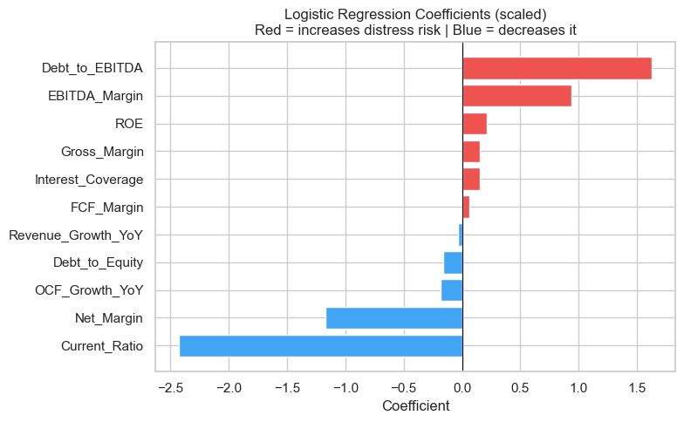

6. SVM — Regularization Effect (C parameter)
Train vs Test F1 as C increases for linear and RBF kernels. At C=100, train F1 reaches 0.998 while test F1 drops — the overfitting signature. Best test F1 occurs at moderate C (RBF, C=10).
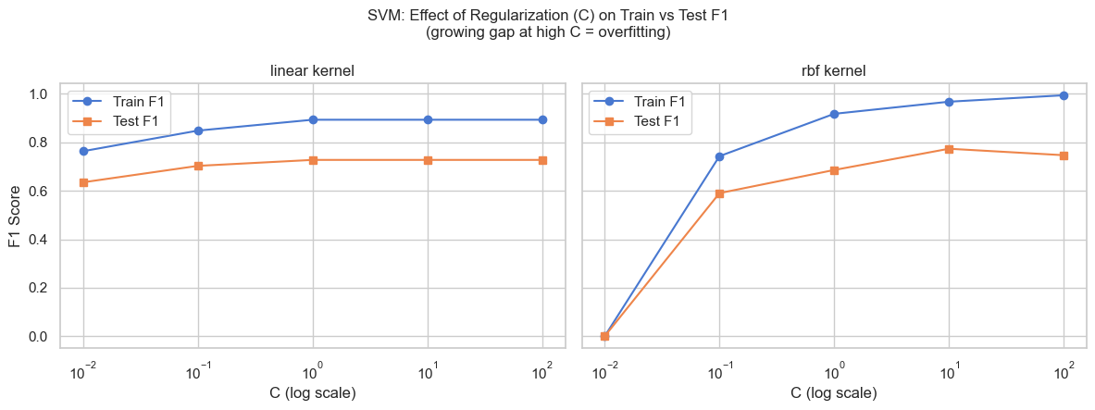

7. Decision Tree — Structure (max_depth=4)
The tree splits first on Current_Ratio, then Interest_Coverage, then Debt_to_EBITDA — exactly the three label-defining ratios. Perfect accuracy (F1=1.000) confirms the tree recovered the exact OR-of-thresholds rule used to construct the Distressed label.
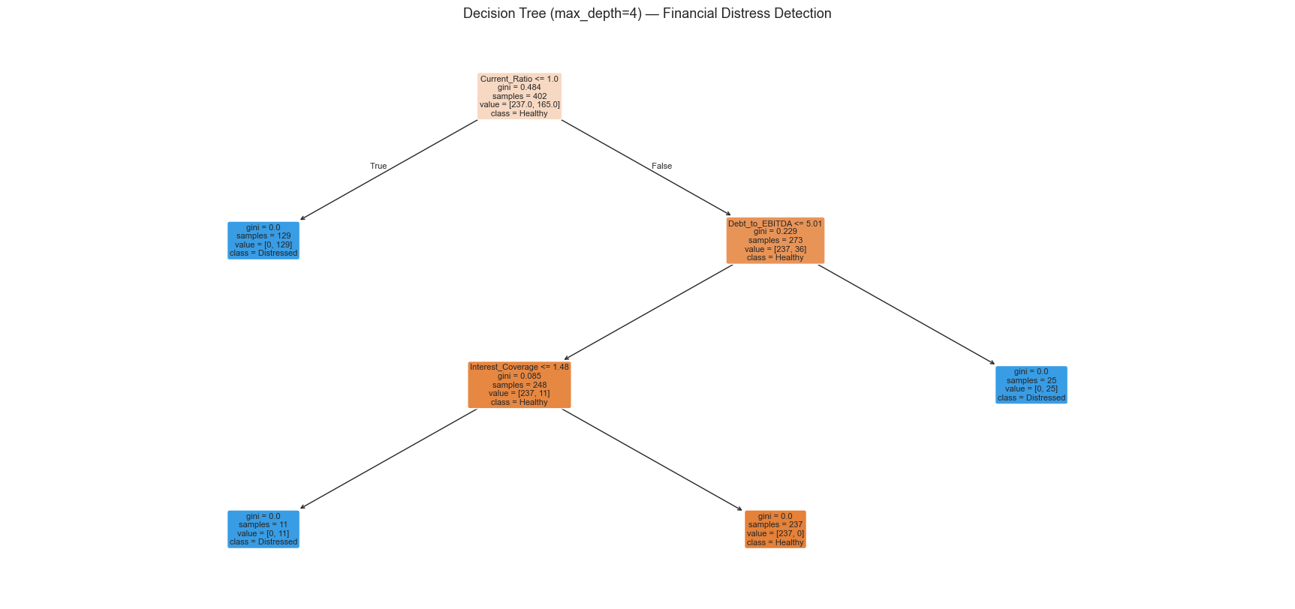

8. Random Forest (Depth)

8a. Bias-Variance Tradeoff — Depth Sweep
Train F1 and Test F1 as max_depth increases. Train F1 climbs toward 1.0 at all depths. Test F1 peaks at depth 6 (the tuned value) and flattens. The growing gap between lines beyond depth 6 is the overfitting signal.
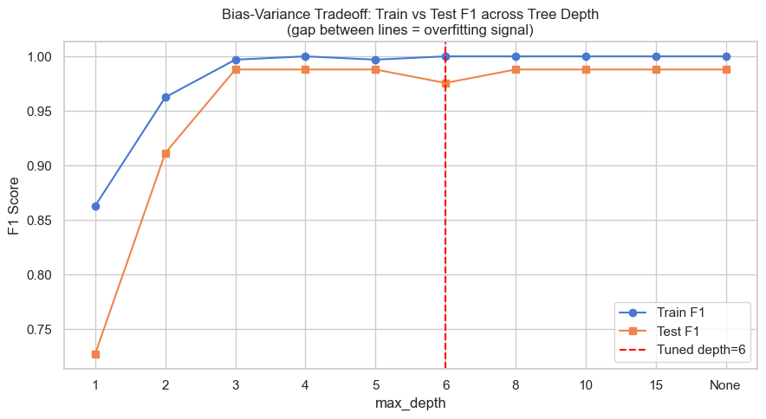

8b. Validation Curve — n_estimators
CV F1 stabilises well before 400 trees. The tuned value (n=50) is the point where adding more trees stops buying meaningful accuracy gain. Shaded area = ±1 standard deviation across CV folds.
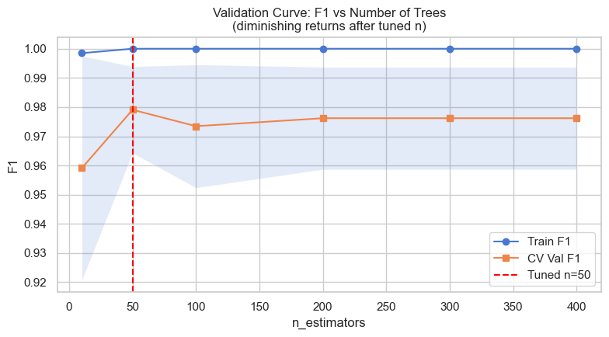

8c. Feature Importances
Current_Ratio ranks highest, followed by Interest_Coverage and Debt_to_EBITDA — the three label-defining ratios. Current_Ratio dominates across all bootstrapped trees, suggesting liquidity is the single most discriminating characteristic between distressed and healthy companies.
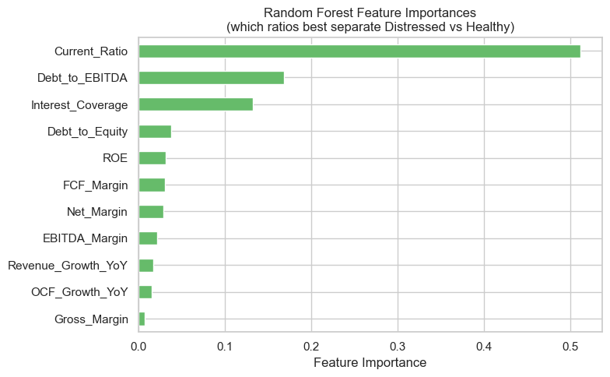

8d. Confusion Matrix
Tuned Random Forest: Precision = 1.000 (no healthy company wrongly flagged as distressed), Recall = 0.952 (misses 4.8% of actually distressed companies). F1 = 0.976.
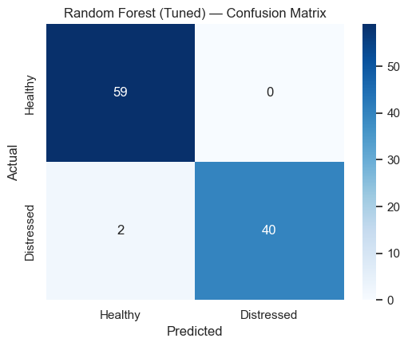

Citations‌
‌
Knaflic, C. N. (2015). Storytelling with Data: A Data Visualization Guide for Business Professionals. Wiley.
Aroussi, Ran. “Yfinance: Yahoo! Finance Market Data Downloader.” PyPI, 2023, pypi.org/project/yfinance/.
Goose, Right. “Financial Performance of Companies from S&P500.” Kaggle.com, 2023, www.kaggle.com/datasets/ilyaryabov/financial-performance-of-companies-from-sp500. Accessed 29 June 2026.
LARXEL. “S&P 500 Stocks (Daily Updated).” Www.kaggle.com, www.kaggle.com/datasets/andrewmvd/sp-500-stocks.
‌Géron, A. (2019). Hands-on machine learning with Scikit-Learn and TensorFlow concepts, tools, and techniques to build intelligent systems (2nd ed.). O’Reilly Media, Inc.
‌

